COLEY STREET SCHOOL
CHARTER
2023

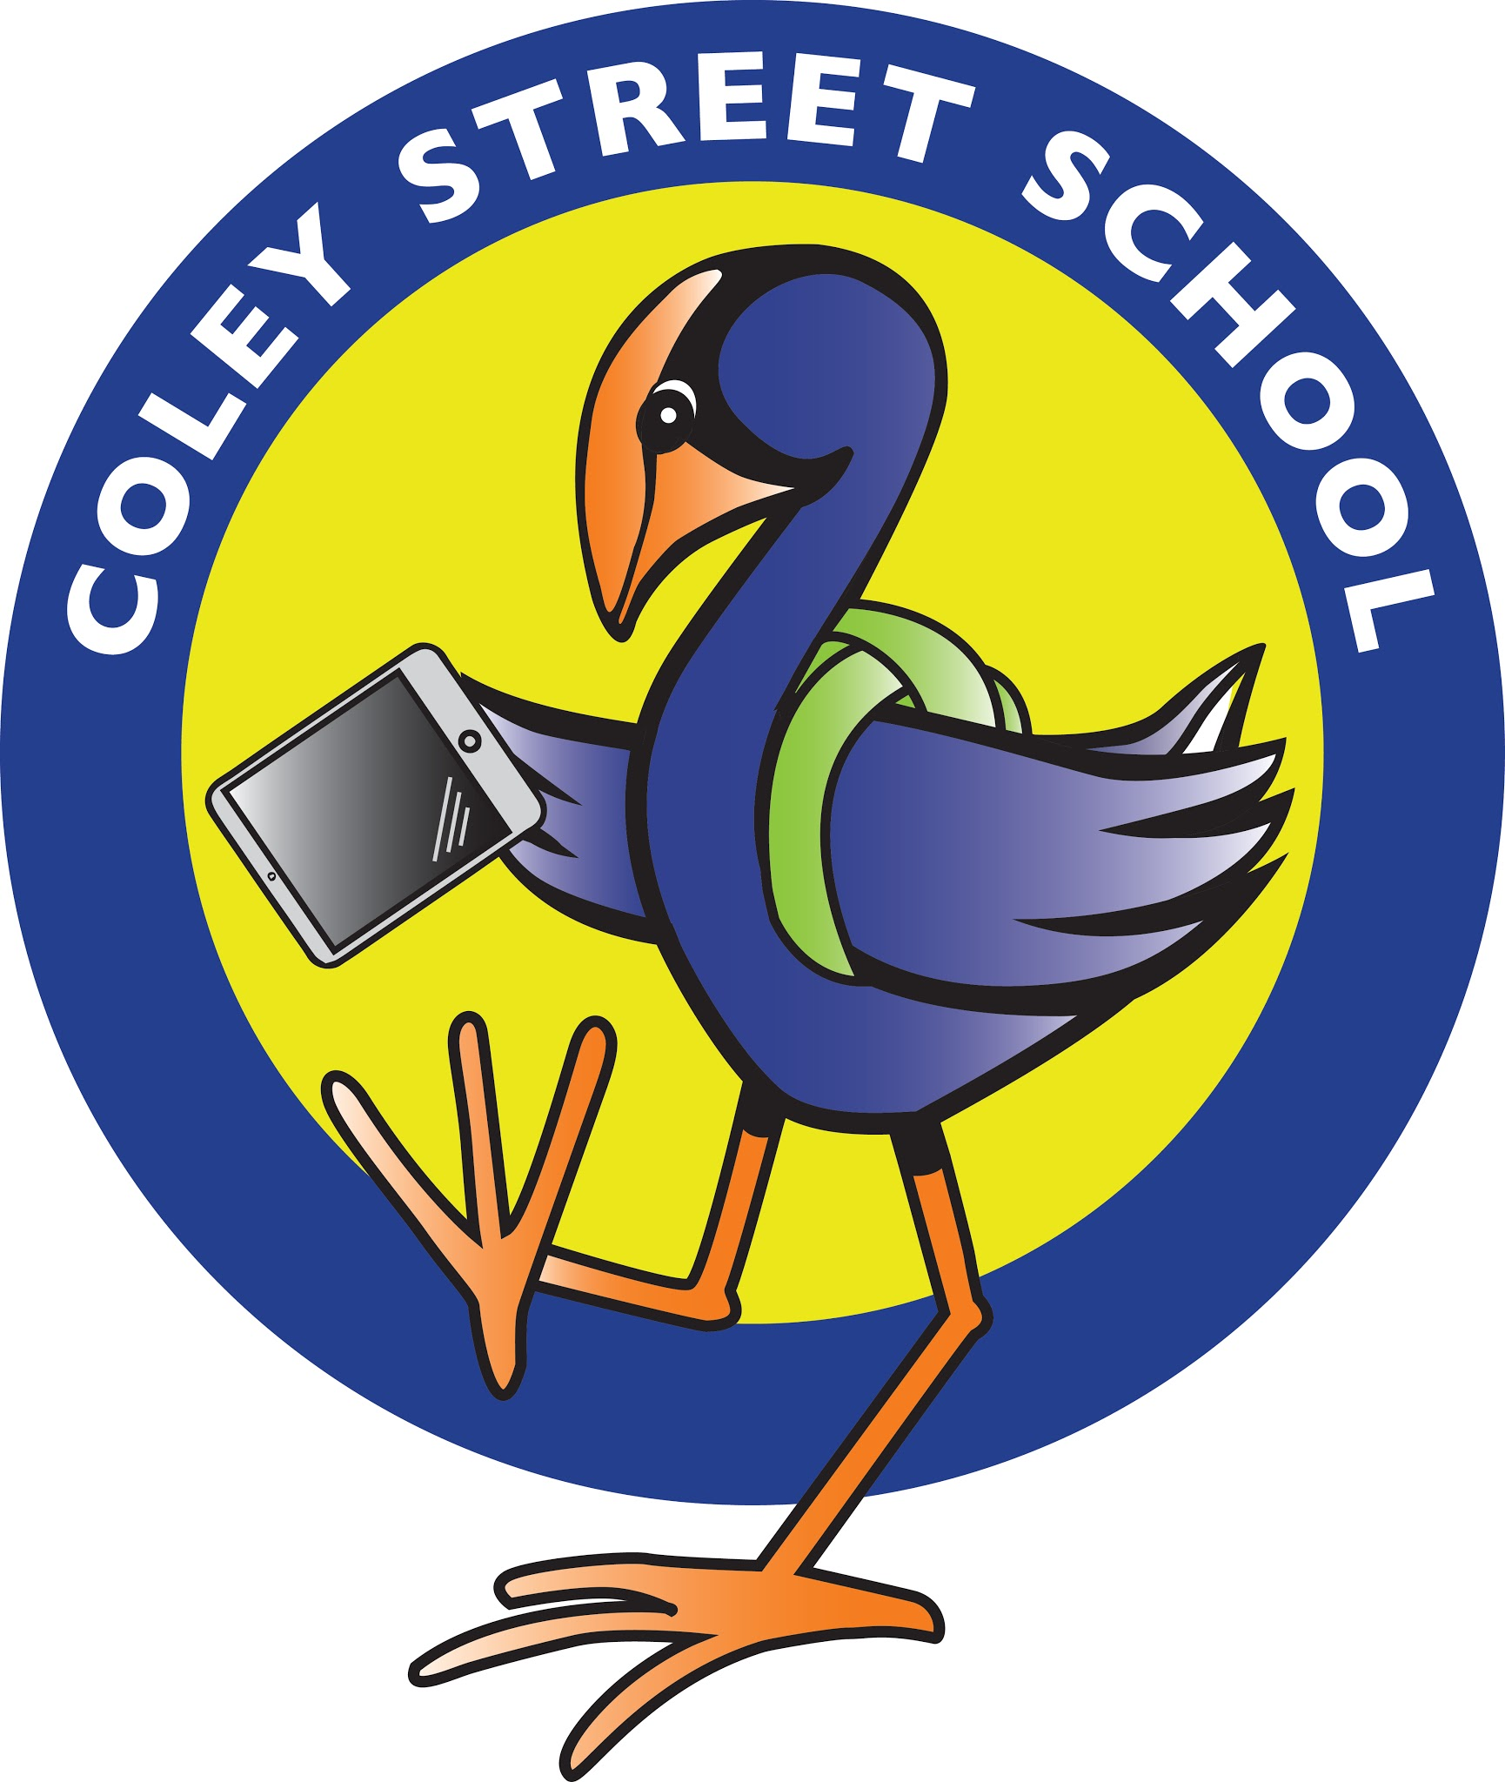
Kia Kaha, Kia Manawaui
To be strong with a big heart
Mission Statement:
At Coley Street School we aim to provide all children with the values, attitudes, and skills for powerful lifelong learning.

CONTENTS

- Coley Street School Strategic Plan: 2023 – 2025

ANNUAL PLAN

- Strategic Aim One
- Strategic Aim Two
- Strategic Aim Three
- Strategic Aim Four
- Strategic Aim Five

OUR COLLECTIVE VISION AND SCHOOL CULTURE
‘Be Strong with a Big Heart’
MISSION STATEMENT
At Coley Street School we aim to provide all children with the values, attitudes, and skills for powerful lifelong learning.
OUR GUIDING PRINCIPLES
At Coley Street School we uphold the beliefs of our learning community by;
- Identifying and focusing on teaching and learning best practice for Maori/Pasifika/Priority learners
- Demonstrating the values of Taha Whanau. Taha Wairua, Taha Hinengaro, Taha Tinana all built on Trust (PB4L)
- Celebrating the pursuit of excellence in academic, sporting and cultural activities
- Children inquiring into authentic and localised contexts by asking questions, exploring possibilities and problem solving
- Encouraging children to be curious, creative and imaginative thinkers who take risks, accept challenges and learn from mistakes
- Enabling children to achieve personal excellence in all learning, through effort, perseverance and the pursuit of foundation knowledge
- Embedding ICT through Manaiakalani into the daily programme which enhances student engagement and learning through the Learn, Create, Share model
- Empowering teachers to be practitioners of best practice, supported by effective professional growth cycles, teacher inquiry and reflection, collaboration, professional learning and well resourced learning spaces.

Our learning community is supported by an environment which;
- Provides a secure physical and emotional context for learning
- Celebrates the bicultural identity of our school community, and develops Whanau Ora within our school and wider community
- Consults with our Raukawa Iwi and community and establishes local tikanga, protocols, stories, legends and history about significant sites.
- Provides a welcoming and inclusive environment with a genuine open door policy
- Utilising the local community partnerships and resources to support a localised curriculum and collaboration in and across schools throughout the Community of Learning

Our Aim is to Develop …Learners who understand and display ….
Te Taha Tinana Te Taha Hinengaro Te Taha Wairua
Achiever Confident Friendly Supportive
Risk Taker Determined Compassionate Tolerant
Courageous Persistent Considerate Loyal
Goal Setter Purposeful Respectful Polite
Committed Curious Celebrate Diversity Sense of Community
Excellence Innovation Environment
Inquiring Participate

Te Taha Whanau
Honesty Trustworthy De Bonos Solo Taxonomy
Truthful Honourable Blooms Graphic Organisers
Self-Disciplined Responsible

In order to develop each ‘Coley Value’ a ‘Coley Kid’ must be able to manage themselves, relate to others, think, use language, symbols and texts, participate & contribute, (the NZC Key Competencies).

CULTURAL DIVERSITY

BACKGROUND

Coley Street School’s student roll is 56% Maori and 43% European and 1% other. Many of the children have affiliation to three local Marae, Poutu, Motuiti and Paranui and the school has established relationships with these Marae. Consultation has been carried out with both the school whanau and the local Iwi. However the school has high expectations for all students in terms of achievement and will continue to monitor Maori / Pacifica / priority learners to ensure their learning success through school and Kere Kere COL data monitoring.

PURPOSE
- To maintain on-going relationships and consult regularly with the Raukawa Iwi and Whanau to ensure parental and community expectations are understood and responded to
- To involve the Whanau and local Iwi/Hapu in the life of the school
- To monitor and further the achievement of Maori / Pacifica students
- To provide for teaching of Tikanga / Protocols and Te Reo Maori through support from Raukawa

PRINCIPLES
- The school will be responsive to the Maori Community
- The Maori community will be represented on the Board of Trustees
- All students and staff will have opportunities to understand and respect Tikanga Maori and speak basic reo
- Opportunities will be available for students to be taught in Te Reo Maori
- The school will have high expectations for Maori student achievement and monitor their progress
- Staff will engage in professional development through Raukawa Teacher Only Days and Resource Teacher of Maori.
- Principal registered on the national Maori Achievement Collaborative.

GUIDELINES
The school takes responsibility for initiating and maintaining processes of consultation:
- Being whanau friendly by maintaining a genuine open door policy
- Regular liaison through Kaiawhina and social worker with the school families
- Visits to local Marae
- Meeting with local Iwi
- Home visits by Management Team / SENCO / LSC / RTLB Liaison
- Attendance at community Tangi
- Utilising a range of communication mediums including face to face contact

Involving the Maori community in the life of the school through:
- School hangi
- Kapa Haka Group
- Sports and Cultural Exchanges
- School Assemblies
- Powhiri/Poroporoaki
- Consultation on curriculum
- Education / Report evenings
- School Prize Giving
- Role models
- School teaching and learning programme
- Localised curriculum

Parents and Whanau are involved in identifying the learning needs of their children and the setting of goals for improvement:
- Parent Interviews and reporting
- IEP’s
- SENCO / LSC / SWIS / RTLB
- ‘Three Way Conferences’ and feedback surveys
- BOT survey
- Consultation survey
- Strengthening Families
- Showcase nights

Monitor and report on the achievement of Maori:
- School review data
- Fortnightly team meetings
- 3 weekly “at risk’ meetings with SENCO / LSC / SWIS / RTLB Liaison
- Management meetings
- Staff meetings
- Reporting to the community and BOT
- MOE Annual Charter and Variance Reports
- Progress against curriculum levels
- Track through school and COL’s data

Foster Te Reo and Tikanga Maori:
- School signage and classroom environments
- Integration of Karakia, Tikanga and Te Reo into daily programmes
- Develop Te Awahou protocols
- Annual powhiri / term powhiri
- Developing our meeting area for Manuhiri at Powhiri with Localised Carvings / Po / new canopy to incorporate our refreshed Coley Values.

Promote Maori Role Models:
- Ex-students celebrating their success
- Prominent Maori members of community visiting the school
- School Leaders
- Kapa Haka Group
- The BOT will act as a good employer in terms of Section 56 of State Services Act 1988
- Scholarship Funding

Students and parents involved in the school Kapa Haka group:
- Regular practices with school wide teaching and learning
- Public performances
- Participation in regional competition
- Assemblies, Powhiri, Poroporoaki, Kapa Haka, Waiata,Mau Rakau, flax weaving

Recognise the place of Maori protocol:
Daily karakia
- Singing National Anthem in Maori and English
- Powhiri and Poroporoaki
- Tangi
- Prize Giving
- Coley Street School protocols

Strategic Plan 2023 - 2025

STRATEGIC AIM | 2023 | 2024 | 2025
- To support the achievement of all students around the priority learning areas of Reading, Writing and Maths, in relation to the New Zealand Curriculum.  Note –‘ Expectation’ means NZ Curriculum expectation | 1.1 Annual targets set based on analysis of a range of 2022 data | Annual targets set based on analysis of a range of 2023 data | Annual targets set based on analysis of a range of 2024 data
 | 1.2 Raised achievement | 1.2 Children working at their expected curriculum level | 1.2 Meeting all target set in charter
 | 1.3 Ongoing collaborative PLD | 1.3 collaborative planning / coaching | 1.3 Students entrenched in Learn creat share
 | 1.4 Ongoing success for Maori supported by Raukawa education Plan | 1.4 Implementing key components of Raukawa Education Plan | 1.4 Transparent community consultation and implementation
 | 1.5 High functioning school. | 1.5 High functioning school | 1.5 School of choice for local community
 | 1.6 Curriculum review ongoing | 1.6 Curriculum review ongoing | 1.6 Ongoing curriculum review
2. To ensure we provide an environment where our school community can be activity engaged in their tamariki teaching and learning. | 2.1 Localised curriculum functioning | 2.1 Localised curriculum supported by the community | 2.1 regular review of localised curriculum
 | 2.2 Community facilitators supporting curriculum | 2.2 well functioning localised curriculum | 2.2 Cohesive planning and implementation school wide curriculum
 | 2.3 Established Iwi connections and consultation | 2.3 Iwi in ongoing supportive role | 2.3 Regular consultation
 | 2.4 Regular ongoing PLD around tikanga / protocols | 2.4 Iwi led teacher only days established | 2.4 Confident connected staff
 | 2.5 students becoming digital contributors | 2.5 Learn, create share model implemented | 2.5 Global contributors
3. To ensure our school wide behaviour management system (PB4L) fosters an environment where tamariki develop the ability to make positive choices that lead to social and academic success supported by whanau. | 3.1 All new staff to attend PLD / national conferences | 3.1 Continual refresh and PLD around PB4L | 3.1 New kaupapa established from 2023
 | 3.2 Ongoing high functioning school. | 3.2 Ongoing high functioning school | 3.3 Children achieving above expectation
 | 3.3 Flagship school in PB4  L | 3.3 Flagship School in PB4L | Integration of new values Glasser / PB4L
 | 3.4 Regularly audited to maintain tier 3 standards | 3.4 Maintain tier 3 status | 3.4 Sustain tier 3
 | 3.5 Ongoing PLD | 3.5 Regular self review | 3.5 Regular refresh , review and PLD
 | 3.6 ongoing review of PB4L systems | 3.6 Ongoing review | 3.5 Meeting the needs of the community
4. To ensure Coley Street School is effectively governed by a Board of Trustees that supports the achievement of all students by providing quality resources and facilities. | 4.1 Ongoing collaboration with BOT, Iwi , community and school | 4.1 Genuine community driven curriculum | 4.1 Meeting the community needs
 | 4.2 High functioning school | 4.2 High functioning school | 4.2 High Functioning school
 | 4.3 Well informed and high functioning BOT | 4.3 Ongoing review | 4.3 BOT that is reflective of the community demographics
 | 4.4 Ongoing review of achievement data to make strategic decisions | 4.4 Charter driven by students data / Iwi / community | 4.4 Charter that is reflective of our community
5.1 To ensure we support the health and well- being of students staff and whanau | 5.1 Healthy high functioning school demonstrating appropriate behaviour and student achievement | 5.2 Children achieving at expectation | 5.2 Children achieving above expectation
 | 5.2 Children achieving at level of expectation | 5.3 Effective support for learning behaviours | 5.3 entrenched school values and kaupapapa from 2023 PLD
 | 5.3 regular communication and effective policies and procedures | 5.4 Ongoing review of all policies | 5.4 Ensuring schooldoc policies meet our needs
 | 5.4 High functioning classrooms with children achieving set targets | 5.5 Safe supportive environment evident | 5.6 Health and well being is paramount
 | 5.5 School health and wellbeing regularly reviewed | 5.6 Refresh policies and procedures | 5.6 Ensuring our school PB4L system is refreshed
 | 5.6 Ongoing review | 5.6 Student voice around health and well being strategies | 5.6 Student led health and well being initiatives

ANNUAL PLAN 2023 STRATEGIC AIM 0NE
To support the achievement of all students, around the priority learning areas of Reading, Writing and Mathematics, in relation to the New Zealand Curriculum.

BASELINE DATA (based on 2022 data):

With our school wide shift to Maths! - No Problem, (based on Singapore Research), we are committed to the key strategies of the change in pedagogy. ( whole class teaching using the CPA model) - concrete, pictorial,abstract, workbooks and textbooks, collaboration, regular use of maths language, keeping all ideas written on the whiteboard, all students working on the same problem and learning to decipher math problems.
We have spent 120 hours on facilitated workshops developing our localised curriculum and invested heavily in the Manaiakalani Programme focusing on digital fluency and the’ Learn, Create, Share model’.

Annual Targets for 2023

Reading: Year 3: 8 students currently Below expectation.
Year 4: 9 students currently Below expectation.
Year 5 & 6 : 15 students currently Below expectation
Year 7: 9 students currently Below expectation.

Writing : Year 3: 6 students currently Below and Well Below expectation.
Year 4: 11 students currently Below expectation.
Year 5 & 6: 12 students currently Below expectation
Year 7 & 8 : 30 students below expectation

Maths: Year 3 : 7 students currently Below expectation.
Year 4: 12 students currently Below expectation.
Year 5 & 6: 14 students currently Below expectation

We aim to progress target students 2 curriculum sub levels or for them to be at the expected curriculum level.

Planning and Assessment
All teachers plan collaboratively and moderation will be completed using the PAT and
E- Asttle assessment tools in middle / senior school and SEA test and the
Phonological Awareness screening at junior school.
Maths! - No Problem assessment at the end of each chapter, middle and end of year.
OTj’s will be made by teachers using a range of data including standardised testing.

STRATEGIC AIM ONE
To support the achievement of all students around the priority learning areas of reading, writing and math in relation to the New Zealand Curriculum.

AIM 1  TARGETS FOR 2023 | Actions to achieve targets | Led By | Budget | Timeframe
1.1 Annual targets set based on the analysis of a range of data in reading, writing and maths | Collate and analyse 2022 data and identify trends around ethnicity, gender and age.  Set targets and budget in strategic plan | BOT / Principal / staff |  | Prior to March 1st
1.2 Priority learners will be identified and appropriate intervention programmes implemented incorporating whanau and school | Support network of SENCO, SWIS, LSC and RTLB to discuss target learners and applications for interventions | SENCO / Principal / staff / support staff |  | Prior to 1st March
1.3 On-going PLD with best practice strategies in teaching and learning consolidated | Specific PLD around localised curriculum, no problem maths, Manaiakalani, MAC programme, PE | Principal / DP | $15,000 | Ongoing
1.4 Established School wide teaching and learning strategies will be evidenced by student achievement and engagement | Collaborative teaching and learning in Manaiakalani, No Problem Maths and Localised curriculum | Staff |  | Ongoing
1.5 Student / teacher / whanau partnerships will be evident with strong levels of shared learning and communication | 3 way conferences with a commitment from all parties to be partners in the student learning | Teachers |  | Ongoing
1.6 Curriculum review and implementation will continue | Ongoing review and data analysis | Principal / staff / BOT |  | Ongoing

STRATEGIC AIM TWO
To ensure we provide an environment where our school community can be actively engaged in the tamariki’s teaching and learning.

AIM 2  TARGETS FOR 2023 | Actions to achieve targets | Led By | Budget | Timeframe
2.1 Whanau will play an active role in localised curriculum | Engage local Iwi / community resource people, companies and resources | Principal / staff |  | Ongoing
2.2 Established protocols for whanau engagement will be evident | Regular consultation | Senior management / staff |  | Ongoing
2.3 Consolidated consultation processes will be established as an aspect of self- review | Raukawa / community representatives included in consultation | Principal / BOT |  | Annually or as required
2.4 School protocols for powhiri and hosting will be a regular event | Establish school wide protocols that are appropriate in a school setting | Staff / Iwi |  | Annual review
2.5 Established processes for open dialogue between home and school | Communication occurs across a number of formats that are inclusive and effective | Principal / Staff |  | Ongoing

STRATEGIC AIM THREE
To ensure our school wide behaviour management system (PB4L) fosters an environment where tamariki develop the ability to make positive choices that lead to social and academic success supported by whanau.

BASELINE DATA:
The established PB4L team is continuously gathering data in relation to play ground and in class behaviour.
This data and information is being used to inform the direction and changes being made to the school wide behaviour management system.

AIM 3  TARGETS FOR 2023 | Actions to achieve targets | Led By | Budget | Timeframe
3.1 School-wide behaviour management system embedded within the school community | Ongoing communication, PLD and tier 2 / 3 training | PB4L team / coach | $4,000 | End of term 1
3.2 School community will demonstrate a clear understanding of the school wide behaviour management system | Encouraging whanau / business community to use common PB4L language with Maori Kaupapa | PB4L Team |  | ongoing
3.3 Noticeable progress in student achievement as a result of PB4L system | Students making accelerated progress in class throughout 2023 as a result of engaged children | PB4L team |  | ongoing
3.4 Restorative practice will be an integral aspect of behaviour management | Attending tier 2 / 3 training with all staff | PB4L Team |  | Throughout 2022-23
3.5 Ensure all documentation regarding PB4L is well communicated and evident in the school environment | Ensure school signage is clearly seen and understood and PB4L data shared amongst staff and students | PB4L team / BOT |  | End of 2023
3.6 PB4L is an integral aspect of the Coley Street School community | PB4L is fully integrated across all school communication and constantly reviewed and refreshed | PB4L Team / Principal / BOT |  | Ongoing

STRATEGIC AIM FOUR
To ensure Coley Street School is effectively governed by a Board of Trustees, that supports the achievement of all students by providing quality resources and facilities.

Aim 4  Targets for 2023 | Actions to achieve targets | Led By | Budget | Timeframe
4.1 The BOT will continue to consult with the school community to formulate the 2023 – 25 charter | Invitation to participate in the writing the charter and consulting with our community will be evident |  |  | Ongoing
4.2 The BOT will review the effectiveness of their strategic planning | At specific times in the year BOT will review their effectiveness | Chairman / Principal |  | 2 times annually
4.3 The BOT will evaluate the effectiveness of their governance process | Through a review process and analysis of variance |  |  | Start of each year
4.4 The BOT will use the achievement data to make strategic decisions | BOT will identify noticings and trends in data | Principal / DP |  | Data discussion at end of each term and data analysis end of the year
4.5 The BOT will consult with the school community to review the 2022 - 24 charter | Through newsletter, survey, facebook, website., Face to face | Principal |  | ongoing
4.6 The BOT will provide a safe physical and emotional environment | Ensuring policies are regularly reviewed and updated and maintaining a complaint register | Principal / office manager |  | Ongoing

STRATEGIC AIM FIVE
To ensure we support the health and well being of students, staff and whanau

Aim 5  Targets for 2023 | Actions to achieve targets | Led By | Budget | Timeframe
5.1 To analyse PB4L data and identify behavioural patterns | Fortnightly analysis of behavioural data | PB4L Data analyser | $4,000
5.2 Through support programmes there will be a focus on health and well being for our community | Fortnighly meetings for our support network, SENCO, LSC, SWIS, RTLB | SENCO |  | ongoing
5.3 Through the school support networks ensure the required support for whanau is available | Early identification of student, whanau at risk / needs analysis | SENCO |  | Ongoing
5.4 Ensure policies and procedures are in place for staff well being | Regular dialogue with Schooldocs for latest policies | BOT / Principal ? staff BOT Rep |  | Ongoing
5.5 To ensure student physical and emotional safety is a priority | Duty staff are effective and there is regular communication across staff, students and whanau | Principal |  | Ongoing
5.6 Policies and procedures in place for safe use of digital technology | ICT contract signed by students and parents and regular student education around ethics | ICT coordinator |  | annually

This charter document is the culmination of newsletter surveys, student voice, teacher, parent / whanau, community, Iwi consultation and Board of Trustees, working together for the betterment of the Coley Street School Community. It also links with the Raukawa Education Plan and Community of Learning levers of change (1) seamless pathways,(2) adaptive, Innovative teaching and learning strategies, (3)
meaningful relations (4) Holistic well being.
We have also refreshed our localised Coley Curriculum with Te Reo terms for our schools values which replace the Coley Hearts.

